Govt. Polytechnic College Bhikhiwind



A MINER PROJECT REPORT ON STUDENT REPORT CARD IN C++

COMPUTER ENGINEERING

IN

5th SEMESTER

SUBMITTED TO: SUBMITTED BY:
Mr. Amarjit Singh Harpreet kaur Reg.No.206024
Davindejit kaur Reg.No.206021
Karamjit kaur Reg.No.226675
Sukhdeep kaur Reg.No.226684

TABLE OF CONTENTS

Sr. no. | NAME | PAGE NO.
1. | Acknowledgement | 3
2. | Abstract of project | 4
3. | Introduction of c++ | 5-12
4. | Screens | 16-21
5. | Coding | 22-35
6. | About of project | 36
7. | Conclusion | 37
8. | Scope of future | 38
9. | Bibliography | 39

ACKNOWLEDGEMENT

This project is dedicated to Mr. Amarjit Singh Lecturer Govt. Polytechnic College Bhikhiwind ,who supported us in our need of our when we were making this project. We made this project in miner project on c++ language.it would be our utmost Pleasure to express our sincere thanks to our miner project teacher . Mr. Amarjit Singh in providing a helping hand in this project.His patience,Creativity and immense knowledge that he shared with our proved highly beneficial to our and made my project file both possible and successful.

SUBMITTED BY:
Harpreet kaur Reg.No.206024
Davindejit kaur Reg.No.206021
Karamjit kaur Reg.No.226675
Sukhdeep kaur Reg.No.226684

ABSTRACT

This project is used to keep the record of student report card in the school. The main purpose of this project is

Display the main menu

Display the result menu show the result of student

Enter and edit display the record of student

Search the record of student-in this we search about student.

Exit- this option is used to the exit of project.

INTRODUCTION OF C++
Programming
A digital computer is a useful tool for solving a great variety of problems. A
solution to a problem is called an algorithm; it describes the sequence of steps to
be performed for the problem to be solved. A simple example of a problem and an
algorithm for it would be:
Problem: Sort a list of names in ascending lexicographic order.
Algorithm: Call the given list list1; create an empty list, list2, to hold the sorted list.
Repeatedly find the ‘smallest’ name in list1, remove it from list1, and
make it the next entry of list2, until list1 is empty.
An algorithm is expressed in abstract terms. To be intelligible to a computer, it
needs to be expressed in a language understood by it. The only language really
understood by a computer is its own machine language. Programs expressed in
the machine language are said to be executable. A program written in any other
language needs to be first translated to the machine language before it can be
executed.
A machine language is far too cryptic to be suitable for the direct use of
programmers. A further abstraction of this language is the assembly language
which provides mnemonic names for the instructions and a more intelligible notation
for the data. An assembly language program is translated to machine language by a
translator called an assembler.
Even assembly languages are difficult to work with. High-level languages such
as C++ provide a much more convenient notation for implementing algorithms.
They liberate programmers from having to think in very low-level terms, and help
them to focus on the algorithm instead. A program written in a high-level language
is translated to assembly language by a translator called a compiler. The assembly
code produced by the compiler is then assembled to produce an executable programs .
C++ originated with Bjarne Stroustrop. In the simplest sense, if not the most accurate, we can consider it to be a better C. Although it is not an entirely new language, C++ represents a significant extension of C abilities. We might then consider C to be a subset of C++. C++ supports essentially every desirable behavior and most of the undesirable ones of its predecessor, but provides general language improvements as well as adding OOP capability. This tutorial is a collection of lectures to be held in the on-line course Introduction to Object-Oriented Programming Using C++ . In this course, object-orientation is introduced as a new programming concept which should help you in developing high quality software. Object-orientation is also introduced as a concept which makes developing of projects easier. However, this is not a course for learning the C++ programming language. If you are interested in learning the language itself, you might want to go through other tutorials, such as C++: Annotations by Frank Broken and Karel Kubat. In this tutorial only those language concepts that are needed to present coding examples are introduced. And what makes object-orientation such a hot topic? To be honest, not everything that is sold under the term of object-orientation is really new. For example, there are programs written in procedural languages like Pascal or C which use object-oriented concepts. But there exist a few important features which these languages won't handle or won't handle very well, respectively. Some people will say that object-orientation is ``modern''. When reading announcements of new products everything seems to be ``object-oriented''. ``Objects'' are everywhere. In this tutorial we will try to outline characteristics of object-orientation to allow you to judge those object-oriented products.
The designers of C++ wanted to add object-oriented mechanisms without compromising the efficiency and simplicity that made C so popular. One of the driving principles for the language designers was to hide complexity from the programmer, allowing her to concentrate on the problem at hand. Because C++ retains C as a subset, it gains many of the attractive features of the C language, such as efficiency, closeness to the machine, and a variety of built-in types. A number of new features were added to C++ to make the language even more robust, many of which are not used by novice programmers. By introducing these new features here, we hope that you will begin to use them in your own programs early on and gain their benefits. Some of the features we will look at are the role of constants, inline expansion, references, declaration statements, user defined types, overloading, and the free store. Most of these features can be summarized by two important design goals: strong compiler type checking and a user-extensible language. By enforcing stricter type-checking, the C++ compiler makes us acutely aware of data types in our expressions. Stronger type checking is provided through several mechanisms, including: function argument type checking, conversions, and a few other features we will examine below.
C++ also enables programmers to incorporate new types into the language, through the use of classes. A class is a user-defined type. The compiler can treat new types as if they are one of the built-in types. This is a very powerful feature. In addition, the class provides the mechanism for data abstraction and encapsulation, which are key to object-oriented programming. As we examine some of the new features of C++ we will see these two goals resurface again and again.
Object Oriented programming paradigms
Class
This chapter introduces the class construct of C++ for defining new data types. A
data type consists of two things:
• A concrete representation of the objects of the type.
• A set of operations for manipulating the objects.
Added to these is the restriction that, other than the designated operations, no
other operation should be able to manipulate the objects. For this reason, we often
say that the operations characterize the type, that is, they decide what can and
what cannot happen to the objects. For the same reason, proper data types as
such are often called abstract data types – abstract because the internal
representation of the objects is hidden from operations that do not belong to the
type.
A class definition consists of two parts: header and body. The class header
specifies the class name and its base classes. (The latter relates to derived classes
and is discussed in Chapter 8.) The class body defines the class members. Two
types of members are supported:
• Data members have the syntax of variable definitions and specify the
representation of class objects.
• Member functions have the syntax of function prototypes and specify the
class operations, also called the class interface.
Class members fall under one of three different access permission categories:
• Public members are accessible by all class users.
• Private members are only accessible by the class members.
• Protected members are only accessible by the class members and the
members of a derived class.
The data type defined by a class is used in exactly the same way as a built-in
type.
Abstract Classes
With inheritance we are able to force a subclass to offer the same properties like their superclasses. Consequently, objects of a subclass behave like objects of their superclasses.
Sometimes it make sense to only describe the properties of a set of objects without knowing the actual behaviour beforehand. In our drawing program example, each object should provide a method to draw itself on the drawing area. However, the necessary steps to draw an objects depends on its represented shape. For example, the drawing routine of a circle is different from the drawing routine of a rectangle.
Derived Classes

In practice, most classes are not entirely unique, but rather variations of existing
ones. Consider, for example, a class named RecFile which represents a file of
records, and another class named SortedRecFile which represents a sorted file
of records. These two classes would have much in common. For example, they
would have similar member functions such as Insert, Delete, and Find, as well
as similar data members. In fact, SortedRecFile would be a specialized version
of RecFile with the added property that its records are organized in sorted order.
Most of the member functions in both classes would therefore be identical, while a
few which depend on the fact that file is sorted would be different. For example,
Find would be different in SortedRecFile because it can take advantage of the
fact that the file is sorted to perform a binary search instead of the linear search
performed by the Find member of RecFile.
Given the shared properties of these two classes, it would be tedious to have
to define them independently. Clearly this would lead to considerable duplication of
code. The code would not only take longer to write it would also be harder to
maintain: a change to any of the shared properties would have to be consistently
applied to both classes.
Object-oriented programming provides a facility called inheritance to
address this problem. Under inheritance, a class can inherit the properties of an
existing class. Inheritance makes it possible to define a variation of a class without
redefining the new class from scratch. Shared properties are defined only once, and
reused as often as desired.
In C++, inheritance is supported by derived classes. A derived class is like
an ordinary class, except that its definition is based on one or more existing classes,
called base classes. A derived class can share selected properties (function as
well as data members) of its base classes, but makes no changes to the definition of
any of its base classes. A derived class can itself be the base class of another
derived class. The inheritance relationship between the classes of a program is
called a class hierarchy.
A derived class is also called a subclass, because it becomes a subordinate of
the base class in the hierarchy. Similarly, a base class may be called a superclass,
because from it many other classes may be derived.

Objects
C++ introduces object-oriented (OO) features to C. It offers classes, which provide the four features commonly present in OO (and some non-OO) languages: abstraction, encapsulation, inheritance, and polymorphism. Objects are instances of classes created at runtime. The class can be thought of as a template from which many different individual objects may be generated as a program runs.
Encapsulation
Encapsulation is the hiding of information in order to ensure that data structures and operators are used as intended and to make the usage model more obvious to the developer. C++ provides the ability to define classes and functions as its primary encapsulation mechanisms. Within a class, members can be declared as either public, protected, or private in order to explicitly enforce encapsulation. A public member of the class is accessible to any function. A private member is accessible only to functions that are members of that class and to functions and classes explicitly granted access permission by the class ("friends"). A protected member is accessible to members of classes that inherit from the class in addition to the class itself and any friends.
The OO principle is that all of the functions (and only the functions) that access the internal representation of a type should be encapsulated within the type definition. C++ supports this (via member functions and friend functions), but does not enforce it: the programmer can declare parts or all of the representation of a type to be public, and is allowed to make public entities that are not part of the representation of the type. Because of this, C++ supports not just OO programming, but other weaker decomposition paradigms, like modular programming.
It is generally considered good practice to make all data private or protected, and to make public only those functions that are part of a minimal interface for users of the class. This hides all the details of data implementation, allowing the designer to later fundamentally change the implementation without changing the interface in any way.

Inheritance
Inheritance allows one data type to acquire properties of other data types. Inheritance from a base class may be declared as public, protected, or private. This access specifier determines whether unrelated and derived classes can access the inherited public and protected members of the base class. Only public inheritance corresponds to what is usually meant by "inheritance". The other two forms are much less frequently used. If the access specifier is omitted, a "class" inherits privately, while a "struct" inherits publicly. Base classes may be declared as virtual; this is called virtual inheritance. Virtual inheritance ensures that only one instance of a base class exists in the inheritance graph, avoiding some of the ambiguity problems of multiple inheritance.
Multiple inheritance is a C++ feature sometimes considered controversial. Multiple inheritance allows a class to be derived from more than one base class; this can result in a complicated graph of inheritance relationships. For example, a "Flying Cat" class can inherit from both "Cat" and "Flying Mammal". Some other languages, such as Java or C#, accomplish something similar (although more limited) by allowing inheritance of multiple interfaces while restricting the number of base classes to one (interfaces, unlike classes, provide only declarations of member functions, no implementation or member data). Interfaces and abstract classes in Java and C# can be approximated in C++ as a class containing only function declarations, often known as an abstract base class or "ABC." Programmers preferring the Java/C# model of inheritance can choose to inherit only one non-abstract class, although in this case the declared member functions of the abstract base classes must be explicitly defined and cannot be inherited. Polymorphism
Polymorphism enables one common interface for many implementations, and for objects to act differently under different circumstances.
C++ supports several kinds of static (compile-time) and dynamic (run-time) polymorphisms. Compile-time polymorphism does not allow for certain run-time decisions, while run-time polymorphism typically incurs a performance penalty.
Static polymorphism
Function overloading allows programs to declare multiple functions having the same name (but with different arguments). The functions are distinguished by the number and/or types of their formal parameters. Thus, the same function name can refer to different functions depending on the context in which it is used. The type returned by the function is not used to distinguish overloaded functions.
When declaring a function, a programmer can specify default arguments for one or more parameters. Doing so allows the parameters with defaults to optionally be omitted when the function is called, in which case the default arguments will be used. When a function is called with fewer arguments than there are declared parameters, explicit arguments are matched to parameters in left-to-right order, with any unmatched parameters at the end of the parameter list being assigned their default arguments. In many cases, specifying default arguments in a single function declaration is preferable to providing overloaded function definitions with different numbers of parameters.
Templates in C++ provide a sophisticated mechanism for writing generic, polymorphic code. In particular, through the Curiously Recurring Template Pattern it's possible to implement a form of static polymorphism that closely mimics the syntax for overriding virtual functions. Since C++ templates are type-aware and Turing-complete they can also be used to let the compiler resolve recursive conditionals and generate substantial programs through template metaprogramming.
Dynamic polymorphism
C++ also provides a dynamic_cast operator, which allows the program to safely attempt conversion of an object into an object of a more specific object type (as opposed to conversion to a more general type, which is always allowed). This feature relies on run-time type information (RTTI). Objects known to be of a certain specific type can also be cast to that type with static_cast, a purely compile-time construct which is faster and does not require RTTI.
Virtual member functions
Ordinarily when a function in a derived class overrides a function in a base class, the function to call is determined by the type of the object. A given function is overridden when there exists no difference, in the number or type of parameters, between two or more definitions of that function. Hence, at compile time it may not be possible to determine the type of the object and therefore the correct function to call, given only a base class pointer; the decision is therefore put off until runtime. This is called dynamic dispatch. Virtual member functions or methods allow the most specific implementation of the function to be called, according to the actual run-time type of the object. In C++, this is commonly done using virtual function tables. If the object type is known, this may be bypassed by prepending a fully qualified class name before the function call, but in general calls to virtual functions are resolved at run time.
In addition to standard member functions, operator overloads and destructors can be virtual. A general rule of thumb is that if any functions in the class are virtual, the destructor should be as well. As the type of an object at its creation is known at compile time, constructors, and by extension copy constructors, cannot be virtual. Nonetheless a situation may arise where a copy of an object needs to be created when a pointer to a derived object is passed as a pointer to a base object. In such a case a common solution is to create a clone() (or similar) function and declare that as virtual. The clone() method creates and returns a copy of the derived class when called.
A member function can also be made "pure virtual" by appending it with = 0 after the closing parenthesis and before the semicolon. Objects cannot be created of a class with a pure virtual function and are called abstract data types. Such abstract data types can only be derived from. Any derived class inherits the virtual function as pure and must provide a non-pure definition of it (and all other pure virtual functions) before objects of the derived class can be created. A program that attempts to create an object of a class with a pure virtual member function or inherited pure virtual member function is ill-formed.
MESSAGE---[Definition (Message) A message is a request to an object to invoke one of its methods. A message therefore contains
the name of the method and
the arguments of the method.
Consequently, invocation of a method is just a reaction caused by receipt of a message. This is only possible, if the method is actually known to the object.
Definition (Method) A method is associated with a class. An object invokes a method as a reaction to receipt of a message.
Operators and operator overloading
C++ provides more than 30 operators, covering basic arithmetic, bit manipulation, indirection, comparisons, logical operations and others. Almost all operators can be overloaded for user-defined types, with a few notable exceptions such as member access (. and .*). The rich set of overloadable operators is central to using C++ as a domain specific language. The overloadable operators are also an essential part of many advanced C++ programming techniques, such as smart pointers. Overloading an operator does not change the precedence of calculations involving the operator, nor does it change the number of operands that the operator uses (any operand may however be ignored).
Constructors
It is possible to define and at the same time initialize objects of a class. This is
supported by special member functions called constructors. A constructor always
has the same name as the class itself. It never has an explicit return type. For
example,
class Point {
int xVal, yVal;
public:
Point (int x,int y) {xVal = x; yVal = y;} // constructor
void OffsetPt (int,int);
};
is an alternative definition of the Point class, where SetPt has been replaced by a
constructor, which in turn is defined to be inline.
Now we can define objects of type Point and initialize them at once. This is
in fact compulsory for classes that contain constructors that require arguments:
Point pt1 = Point(10,20);
Point pt2; // illegal!
The former can also be specified in an abbreviated form.
Point pt1(10,20);
A class may have more than one constructor. To avoid ambiguity, however,
each of these must have a unique signature. For example,
class Point {
int xVal, yVal;
public:
Point (int x, int y) { xVal = x; yVal = y; }
Point (float, float); // polar coordinates
Point (void) { xVal = yVal = 0; } // origin
void OffsetPt (int, int);
};
Point::Point (float len, float angle) // polar coordinates
{
xVal = (int) (len * cos(angle));
yVal = (int) (len * sin(angle));
}
offers three different constructors. An object of type Point can be defined using
any of these:
Point pt1(10,20); // cartesian coordinates
Point pt2(60.3,3.14); // polar coordinates
Point pt3; // origin
Destructors
Just as a constructor is used to initialize an object when it is created, a destructor is
used to clean up the object just before it is destroyed. A destructor always has the
same name as the class itself, but is preceded with a ~ symbol. Unlike constructors,
a class may have at most one destructor. A destructor never takes any arguments
and has no explicit return type.
Destructors are generally useful for classes which have pointer data members
which point to memory blocks allocated by the class itself. In such cases it is
important to release member-allocated memory before the object is destroyed. A
destructor can do just that.
For example, our revised version of Set uses a dynamically-allocated array
for the elems member. This memory should be released by a destructor:
class Set {
public:
Set (const int size);
~Set (void) {delete elems;} // destructor
//...
private:
int *elems; // set elements
int maxCard; // maximum cardinality
int card; // set cardinality
};
Now consider what happens when a Set is defined and used in a function:
void Foo (void)
{
Set s(10);
//...
}
When Foo is called, the constructor for s is invoked, allocating storage for
s.elems and initializing its data members. Next the rest of the body of Foo is
executed. Finally, before Foo returns, the destructor for s is invoked, deleting the
storage occupied by s.elems. Hence, as far as storage allocation is concerned, s
behaves just like an automatic variable of a built-in type, which is created when its
scope is entered and destroyed when its scope is left.
In general, an object’s constructor is applied just before the object is
destroyed. This in turn depends on the object’s scope. For example, a global
object is destroyed when program execution is completed; an automatic object is
destroyed when its scope is left; and a dynamic object is destroyed when the
delete operator is applied to it. ◻

Array ---
An array consists of a set of objects (called its elements), all of which are of the same type and are arranged contiguously in memory. In general, only the array itself has a symbolic name, not its elements. Each element is identified by an index which denotes the position of the element in the array. The number of elements in an array is called its dimension. The dimension of an array is fixed and predetermined; it cannot be changed during program execution. Arrays are suitable for representing composite data which consist of many similar, individual items. Examples include: a list of names, a table of world cities and their current temperatures, or the monthly transactions for a bank account.

Pointers:
A pointer is simply the address of an object in memory. Generally, objects can be accessed in two ways: directly by their symbolic name, or indirectly through a pointer. The act of getting to an object via a pointer to it, is called dereferencing the pointer. Pointer variables are defined to point to objects of a specific type so that when the pointer is dereferenced, a typed object is obtained. Pointers are useful for creating dynamic objects during program execution. Unlike normal (global and local) objects which are allocated storage on the runtime stack, a dynamic object is allocated memory from a different storage area called the heap. Dynamic objects do not obey the normal scope rules. Their scope is explicitly controlled by the programmer. A reference provides an alternative symbolic name (alias) for an object. Accessing an object through a reference is exactly the same as accessing it through its original name. References offer the power of pointers and the convenience of direct access to objects. They are used to support the call-by-reference style of function parameters, especially when large objects are being passed to functions.
Structures and unions
A structure is a class all of whose members are by default public. (Remember that
all of the members of a class are by default private.) Structures are defined using
the same syntax as classes, except that the keyword struct is used instead of
class. For example,
struct Point {
Point (int, int);
void OffsetPt (int, int);
int x, y;
};
is equivalent to:
class Point {
public:
Point (int, int);
void OffsetPt (int, int);
int x, y;
};
The struct construct originated in C, where it could only contain data
members. It has been retained mainly for backward compatibility reasons. In C, a
structure can have an initializer with a syntax similar to that of an array. C++ allows
such initializers for structures and classes all of whose data members are public:
class Employee {
public:
char *name;
int age;
double salary;
};
Employee emp = {"Jack", 24, 38952.25};
The initializer consists of values which are assigned to the data members of the
structure (or class) in the order they appear. This style of initialization is largely
superseded by constructors. Furthermore, it cannot be used with a class that has a
constructor.
A union is a class all of whose data members are mapped to the same
address within its object (rather than sequentially as is the case in a class). The size
of an object of a union is, therefore, the size of its largest data member.
The main use of unions is for situations where an object may assume values of
different types, but only one at a time. For example, consider an interpreter for a
simple programming language, called P, which supports a number of data types
such as: integers, reals, strings, and lists. A value in this language may be defined to
be of the type:
Function declarations and definitions
The distinction between a function declaration and function definition is similar to that of a data declaration and definition. The declaration establishes the names and characteristics of a function but does not allocate storage for it, while the definition allocates specifies the body for a function, associates an identifier with the function, and allocates storage for it. Thus, the identifiers declared in this example:
float square(float x);
do not allocate storage.
The function definition contains a function declaration and the body of a function. The body is a block of statements that perform the work of the function. The identifiers declared in this example allocate storage; they are both declarations and definitions.
float square(float x)
{ return x*x; }
A function can be declared several times in a program, but all declarations for a given function must be compatible; that is, the return type is the same and the parameters have the same type. However, a function can only have one definition. Declarations are typically placed in header files, while definitions appear in source files.
Templates
Templates facilitate the generic definition of functions and classes so that
they are not tied to specific implementation types. They are invaluable in that they
dispense with the burden of redefining a function or class so that it will work with
yet another data type.
A function template defines an algorithm. An algorithm is a generic recipe for
accomplishing a task, independent of the particular data types used for its
implementation. For example, the binary search algorithm operates on a sorted
array of items, whose exact type is irrelevant to the algorithm. Binary search can
therefore be defined as a function template with a type parameter which denotes
the type of the array items. This template then becomes a blueprint for generating
executable functions by substituting a concrete type for the type parameter. This
process is called instantiation and its outcome is a conventional function.
A class template defines a parameterized type. A parameterized type is a
data type defined in terms of other data types, one or more of which are
unspecified. Most data types can be defined independently of the concrete data
types used in their implementation. For example, the stack data type involves a set
of items whose exact type is irrelevant to the concept of stack. Stack can therefore
be defined as a class template with a type parameter which specifies the type of the
items to be stored on the stack. This template can then be instantiated, by
substituting a concrete type for the type parameter, to generate executable stack
classes.
Templates provide direct support for writing reusable code. This in turn makes
them an ideal tool for defining generic libraries.
We will present a few simple examples to illustrate how templates are defined,
instantiated, and specialized. We will describe the use of nontype parameters in
class templates, and discuss the role of class members, friends, and derivations in
the context of class templates.

Screens

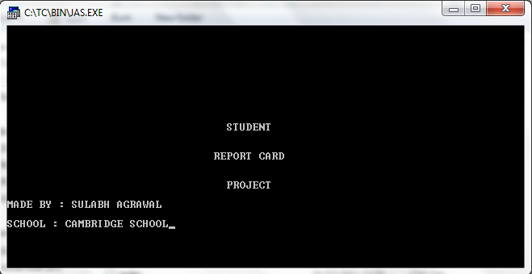

Project Screen 1

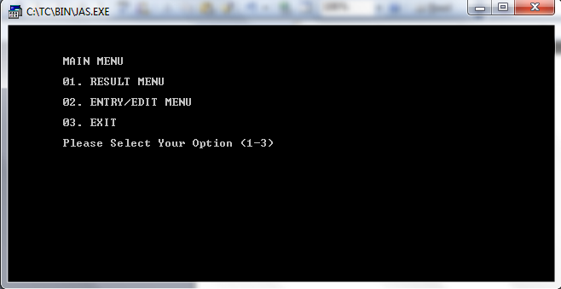

Project Screen 2

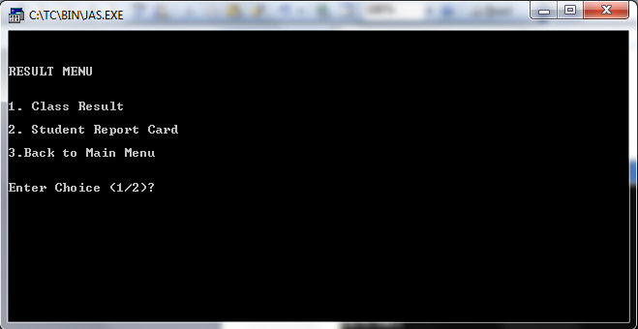

Project Screen 3

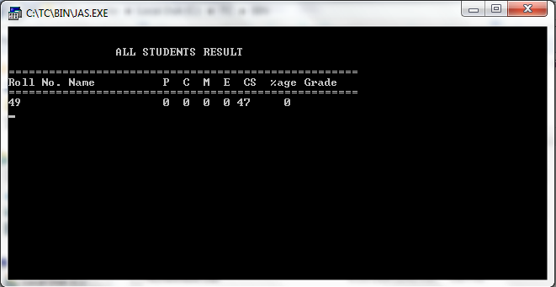

Project Screen 4

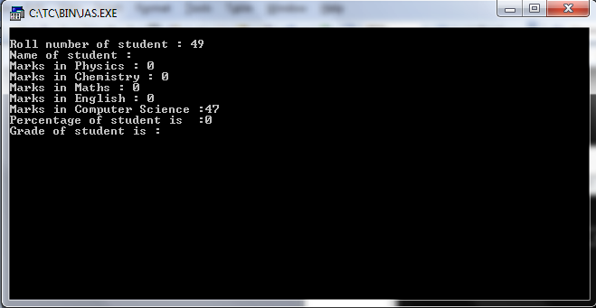

Project Screen 5

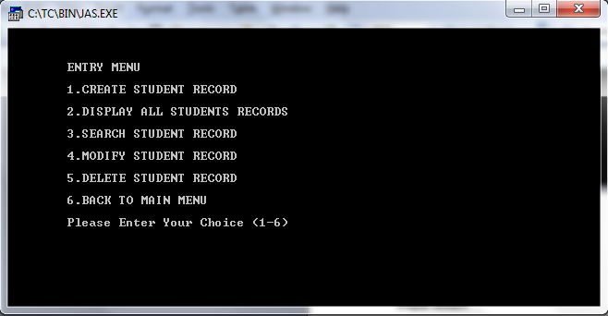

Project Screen 6

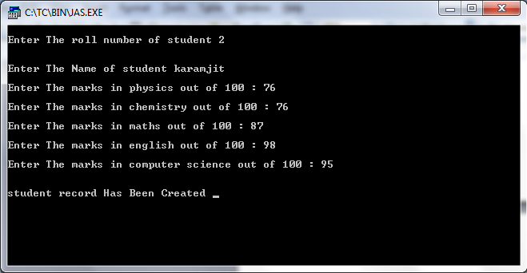

Project Screen 7

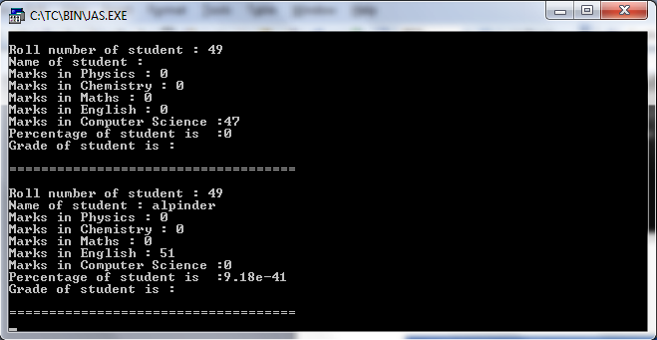

Project Screen 8

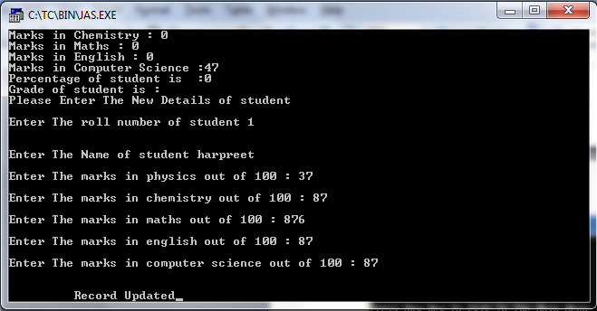

Project Screen 9

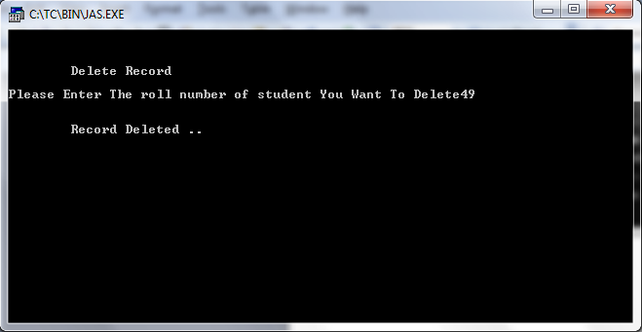

Project Screen 10

Coding

//***************************************************************
// HEADER FILE USED IN PROJECT
//****************************************************************

#include<conio.h>
#include<stdio.h>
#include<process.h>
#include<fstream.h>
#include<iomanip.h>

//***************************************************************
// CLASS USED IN PROJECT
//****************************************************************

class student
{
int rollno;
char name[50];
int p_marks,c_marks,m_marks,e_marks,cs_marks;
float per;
char grade;
int std;
void calculate()
{
per=(p_marks+c_marks+m_marks+e_marks+cs_marks)/5.0;
if(per>=60)
grade='A';
else if(per>=50 && per<60)
grade='B';
else if(per>=33 && per<50)
grade='C';
else
grade='F';
}
public:
void getdata()
{
cout<<"\nEnter The roll number of student ";
cin>>rollno;
cout<<"\n\nEnter The Name of student ";
gets(name);
cout<<"\nEnter The marks in physics out of 100 : ";
cin>>p_marks;
cout<<"\nEnter The marks in chemistry out of 100 : ";
cin>>c_marks;
cout<<"\nEnter The marks in maths out of 100 : ";
cin>>m_marks;
cout<<"\nEnter The marks in english out of 100 : ";
cin>>e_marks;
cout<<"\nEnter The marks in computer science out of 100 : ";
cin>>cs_marks;
calculate();
}

void showdata()
{
cout<<"\nRoll number of student : "<<rollno;
cout<<"\nName of student : "<<name;
cout<<"\nMarks in Physics : "<<p_marks;
cout<<"\nMarks in Chemistry : "<<c_marks;
cout<<"\nMarks in Maths : "<<m_marks;
cout<<"\nMarks in English : "<<e_marks;
cout<<"\nMarks in Computer Science :"<<cs_marks;
cout<<"\nPercentage of student is :"<<setprecision(2)<<per;
cout<<"\nGrade of student is :"<<grade;
}

void show_tabular()
{
cout<<rollno<<setw(12)<<name<<setw(10)<<p_marks<<setw(3)<<c_marks<<setw(3)<<m_marks<<setw(3)<<
e_marks<<setw(3)<<cs_marks<<setw(6)<<setprecision(3)<<per<<" "<<grade<<endl;
}

int retrollno()
{ return rollno; }

}; //class ends here

//***************************************************************
// global declaration for stream object, object
//****************************************************************

fstream fp;
student st;

//***************************************************************
// function to write in file
//****************************************************************

void write_student()
{
fp.open("student.dat",ios::out|ios::app);
st.getdata();
fp.write((char*)&st,sizeof(student));
fp.close();
cout<<"\n\nstudent record Has Been Created ";
getch();
}

//***************************************************************
// function to read all records from file
//****************************************************************

void display_all()
{
clrscr();
cout<<"\n\n\n\t\tDISPLAY ALL RECORD !!!\n\n";
fp.open("student.dat",ios::in);
while(fp.read((char*)&st,sizeof(student)))
{
st.showdata();
cout<<"\n\n====================================\n";
getch();
}
fp.close();
getch();
}

//***************************************************************
// function to read specific record from file
//****************************************************************

void display_sp(int n)
{
int flag=0;
fp.open("student.dat",ios::in);
while(fp.read((char*)&st,sizeof(student)))
{
if(st.retrollno()==n)
{
clrscr();
st.showdata();
flag=1;
}
}
fp.close();
if(flag==0)
cout<<"\n\nrecord not exist";
getch();
}

//***************************************************************
// function to modify record of file
//****************************************************************

void modify_student()
{
int no,found=0;
clrscr();
cout<<"\n\n\tTo Modify ";
cout<<"\n\n\tPlease Enter The roll number of student";
cin>>no;
fp.open("student.dat",ios::in|ios::out);
while(fp.read((char*)&st,sizeof(student)) && found==0)
{
if(st.retrollno()==no)
{
st.showdata();
cout<<"\nPlease Enter The New Details of student"<<endl;
st.getdata();
int pos=-1*sizeof(st);
fp.seekp(pos,ios::cur);
fp.write((char*)&st,sizeof(student));
cout<<"\n\n\t Record Updated";
found=1;
}
}
fp.close();
if(found==0)
cout<<"\n\n Record Not Found ";
getch();
}

//***************************************************************
// function to delete record of file
//****************************************************************

void delete_student()
{
int no;
clrscr();
cout<<"\n\n\n\tDelete Record";
cout<<"\n\nPlease Enter The roll number of student You Want To Delete";
cin>>no;
fp.open("student.dat",ios::in|ios::out);
fstream fp2;
fp2.open("Temp.dat",ios::out);
fp.seekg(0,ios::beg);
while(fp.read((char*)&st,sizeof(student)))
{
if(st.retrollno()!=no)
{
fp2.write((char*)&st,sizeof(student));
}
}
fp2.close();
fp.close();
remove("student.dat");
rename("Temp.dat","student.dat");
cout<<"\n\n\tRecord Deleted ..";
getch();
}

//***************************************************************
// function to display all students grade report
//****************************************************************

void class_result()
{
clrscr();
fp.open("student.dat",ios::in);
if(!fp)
{
cout<<"ERROR!!! FILE COULD NOT BE OPEN\n\n\n Go To Entry Menu to create File";
cout<<"\n\n\n Program is closing ....";
getch();
exit(0);
}
cout<<"\n\n\t\tALL STUDENTS RESULT \n\n";
cout<<"====================================================\n";
cout<<"Roll No. Name P C M E CS %age Grade\n";
cout<<"====================================================\n";
while(fp.read((char*)&st,sizeof(student)))
{
st.show_tabular();
}
fp.close();
getch();
}

//***************************************************************
// function to display result menu
//****************************************************************

void result()
{
int ans,rno;
char ch;
clrscr();
cout<<"\n\n\nRESULT MENU";
cout<<"\n\n\n1. Class Result\n\n2. Student Report Card\n\n3.Back to Main Menu";
cout<<"\n\n\nEnter Choice (1/2)? ";
cin>>ans;
switch(ans)
{
case 1 : class_result();break;
case 2 : {
do{
clrscr();
char ans;
cout<<"\n\nEnter Roll Number Of Student : ";
cin>>rno;
display_sp(rno);
cout<<"\n\nDo you want to See More Result (y/n)?";
cin>>ans;
}while(ans=='y'||ans=='Y');
break;
}
case 3: break;
default: cout<<"\a";
}
}

//***************************************************************
// INTRODUCTION FUNCTION
//****************************************************************

void intro()
{
clrscr();
gotoxy(35,11);
cout<<"STUDENT";
gotoxy(33,14);
cout<<"REPORT CARD";
gotoxy(35,17);
cout<<"PROJECT";
cout<<"\n\nMADE BY : SULABH AGRAWAL";
cout<<"\n\nSCHOOL : CAMBRIDGE SCHOOL";
getch();
}

//***************************************************************
// ENTRY / EDIT MENU FUNCTION
//****************************************************************
void entry_menu()
{
clrscr();
char ch2;
cout<<"\n\n\n\tENTRY MENU";
cout<<"\n\n\t1.CREATE STUDENT RECORD";
cout<<"\n\n\t2.DISPLAY ALL STUDENTS RECORDS";
cout<<"\n\n\t3.SEARCH STUDENT RECORD ";
cout<<"\n\n\t4.MODIFY STUDENT RECORD";
cout<<"\n\n\t5.DELETE STUDENT RECORD";
cout<<"\n\n\t6.BACK TO MAIN MENU";
cout<<"\n\n\tPlease Enter Your Choice (1-6) ";
ch2=getche();
switch(ch2)
{
case '1': clrscr();
write_student();
break;
case '2': display_all();break;
case '3':
int num;
clrscr();
cout<<"\n\n\tPlease Enter The roll number ";
cin>>num;
display_sp(num);
break;
case '4': modify_student();break;
case '5': delete_student();break;
case '6': break;
default:cout<<"\a";entry_menu();
}
}

//***************************************************************
// THE MAIN FUNCTION OF PROGRAM
//****************************************************************

void main()
{
char ch;
intro();
do
{
clrscr();
cout<<"\n\n\n\tMAIN MENU";
cout<<"\n\n\t01. RESULT MENU";
cout<<"\n\n\t02. ENTRY/EDIT MENU";
cout<<"\n\n\t03. EXIT";
cout<<"\n\n\tPlease Select Your Option (1-3) ";
ch=getche();
switch(ch)
{
case '1': clrscr();
result();
break;
case '2': entry_menu();
break;
case '3':exit(0);
default :cout<<"\a";
}
}while(ch!='3');
}

//***************************************************************
// END OF PROJECT
//**************************************************

ABOUT THE PROJECT

This project is used to keep the records of student .The main purpose of this project is easy to see the records of student’s report card in all branches. It is very easy way to see the records of students available in school. With the help of this project we see the issue records of student’s report card. We can see easily about student name, reg.no marks. We can search about student if record of student is available.

CONCLUSION

This project keeps the record of students. It is a very simple project for handle the record of students in school. This project is time saving as it saves the time of the teachers as well as student. It reduced the paper work. The main advantage of this project is that it converts all the manual work which is time consuming and error prone to fully automated system which helps in eliminating all the paper work, saves time, improves library services.

SCOPE IN FUTURE

This project keeps the record of students. It is a very simple project for handle the record of students in school. This project is time saving as it saves the time of the teachers as well as student. It reduced the paper work. The main advantage of this project is that it converts all the manual work which is time consuming and error prone to fully automated system which helps in eliminating all the paper work, saves time, improves library services.

BIBLIOGRAPHY

- Books

- Object Oriented Programming using C++ by :-

Balagurswami

- Object Oriented Programming using C ++ by:-

Sandeep

Websites:
- Altivista.com
- Khoj.com
- www.liveprojects.com

